Comp 376 Project Documentation

**Shattered**

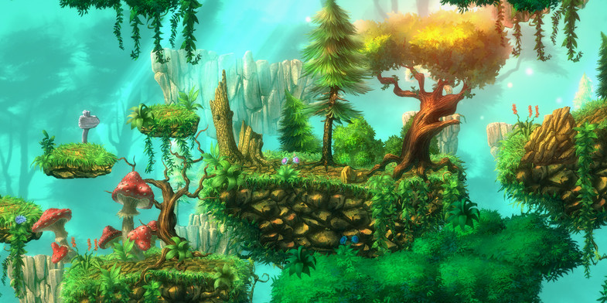

Game Designers:

Reza Madabadi

Skyler Wittman

Zackary Valenta

Zhonghan Zhou

 Executive Summary

The game world consists of four different maps combine together. They are: Forest Kingdom; Cave Kingdom; Frozen Kingdom and Cloud Kingdom. Each map contains different elements that are unique to that kingdom. The player needs to get to certain places to get powerups in order to get to the next stage.

One of the abilities that the player has is a single jump, he can use it to jump over certain obstacles/enemies and from one platform to another. The player is also equipped with a long reaching kick to eliminate enemies. After the player has explored certain areas of the map, he will slowly realized that he needs to get additional power to reach or unlock new areas and sometimes the designers give a little bit of help with a visual cue. The first power up is a spin kick, after the player gets the powerup, it gives them the ability to destroy a rock that is blocking their path in front of the Cave Kingdom, which a normal kick will not destroy. The second ability that the player can find is a double jump, it allows them to jump twice either immediately or staggered so they can get to the Cloud Kingdom and progress to the Boss.

Overview

Genre Action-Platformer

Platform PC

Market Traditional platform gamers. Puzzle lovers. Explorers

Aspects Puzzle-solving, open-world

Age 6 to 99

Plays Like When Donkey Kong meets LittleBigPlanet

Mechanics 1. Open-world

2. Progression

3. Puzzles as obstacles

5. Combat Mechanics/Enemy Weaknesses

Related Games:

1. Donkey Kong: Donkey Kong is one of the earliest examples of the platform game genre. As the first platform game to feature jumping, it requires the player to jump between gaps and over obstacles or approaching enemies, setting the template for the future of the platform genre. With its four unique stages, Donkey Kong was the most complex arcade game at the time of its release, and only the second game to feature multiple stages. SHATTERED takes inspiration from DK by having multiple stages in a larger level and the general platforming aspect of our game.

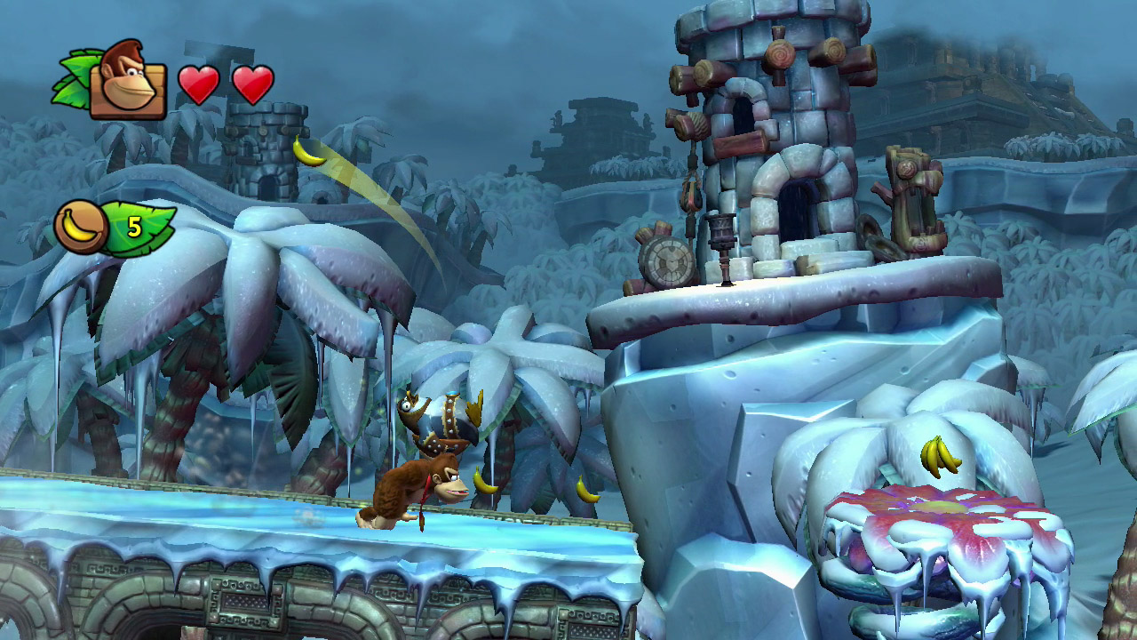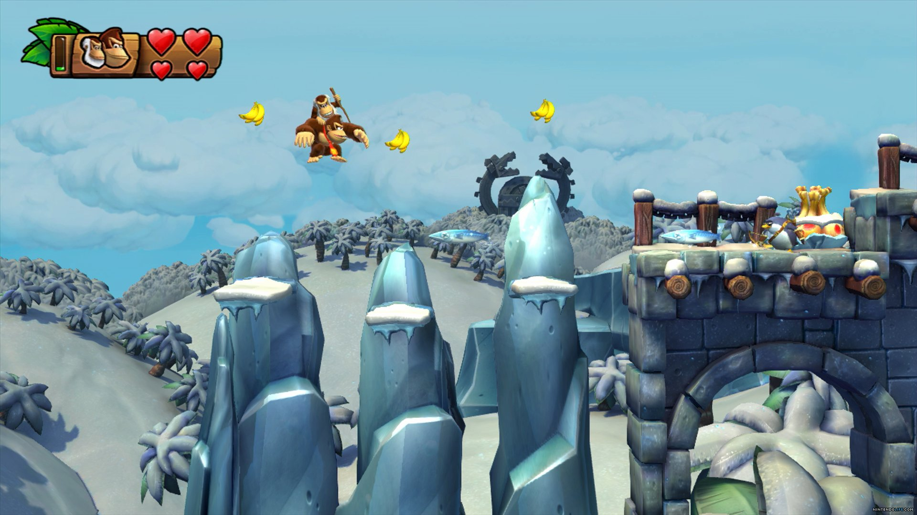

Related Games:

2. LittleBigPlanet: LittleBigPlanet is a puzzle platform video game series.  The series follows the adventures of Sackboy and has a large emphasis on gameplay rather than being story-driven. All of the games in the series put a strong emphasis on user-generated content and are based on the series' tagline "Play, Create, Share". The tagline represents the three core elements of the series; Playing alone or with others online or on the same console, creating new content using the in-game creation tools and sharing creations and discoveries online with other players. SHATTERED takes from LittleBigPlanet the similar movement of the player through the game as they platform as well as the 3D boss aspect.

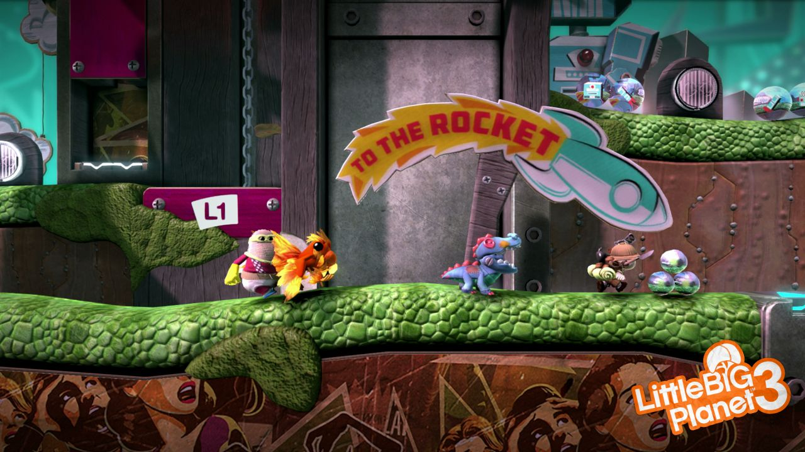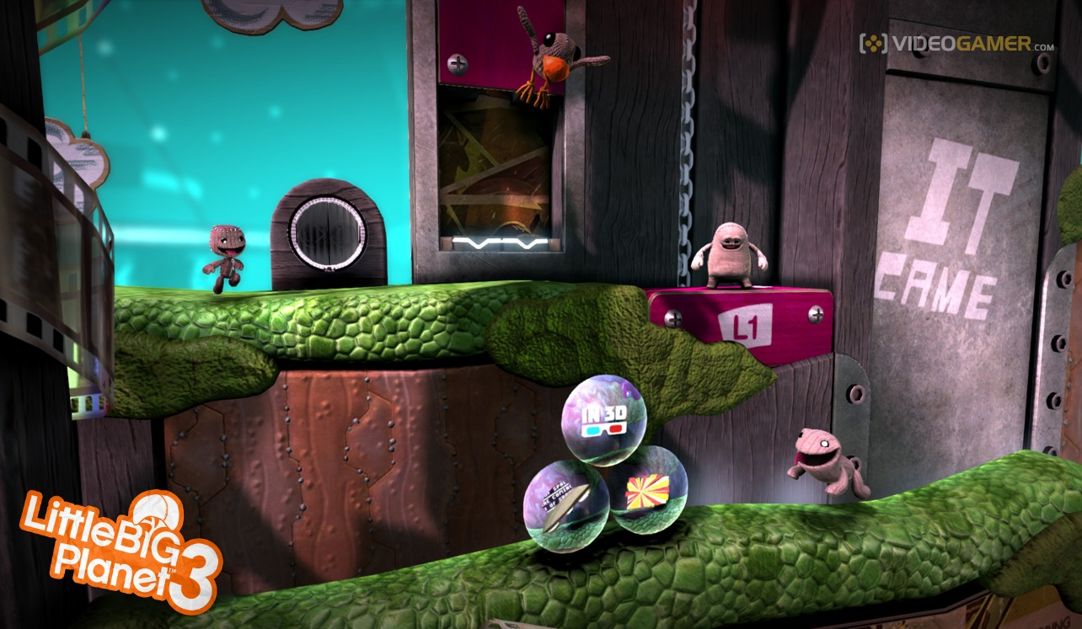

Related Games:

3. Guacamelee!: Guacamelee! is a 2013 action platforming video game developed and published by DrinkBox Studios. The game draws its inspiration from traditional Mexican culture and folklore. In the game players control Juan as he fights his way across various enemies and obstacles in order to rescue El Presidente's daughter. Juan can attack enemies using basic attacks and can perform various grapple attacks when they are stunned, dealing more damage or throwing them towards other enemies. Defeating enemies yields coins that can be spent at certain locations to unlock new grapple attacks or increase the player's health and stamina gauges. Guacamelee also has a similar feel to SHATTERED. We have one of the basic attacks from this game and they have a nice progression even though it’s through currency and not just exploration. We also like the 2D aspect with a 3D boss as we decided to implement.

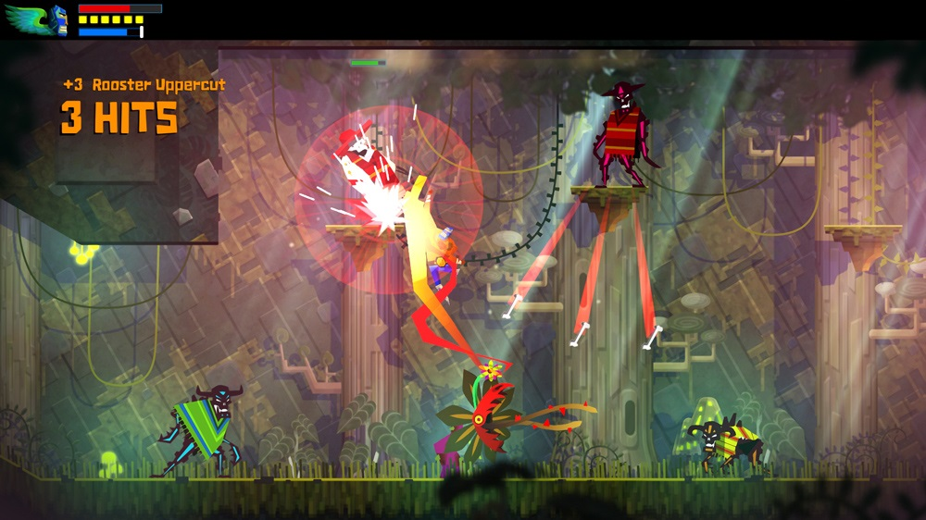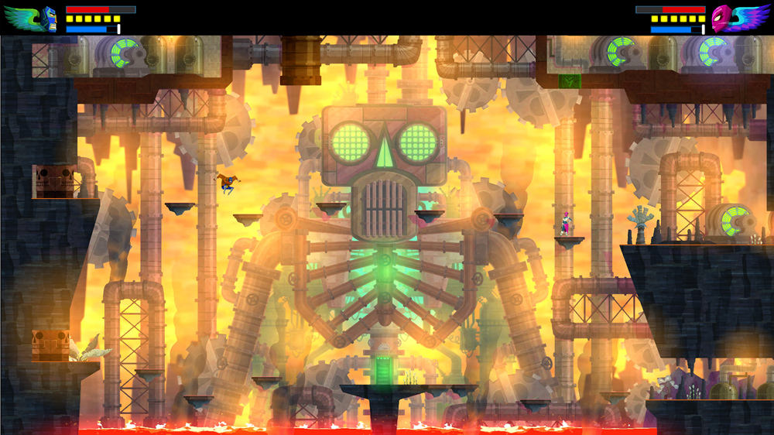

Related Games:

4. Rayman Origins: Rayman Origins is a platform video game developed by Ubisoft Montpellier. The story follows Rayman, his friend Globox and two teensies as they fight Darktoons and other evil creatures that have infected the Glade of Dreams. Players travel through each level, fighting enemies and rescuing imprisoned Electoons. As the game progresses, players gain new abilities such as running up walls, gliding in midair, swimming and shrinking in size to reach new areas. Certain segments also see players riding a mosquito, where players can shoot enemies or suck them up and fire them. We got a lot of inspiration from Rayman for SHATTERED by having the unlockable abilities, as well as the flow of the game. If we had had more time it would have been cool to borrow some of their mechanics like swimming, shrinking etc. Our art also borrows heavily from Rayman especially the jungle/forest areas

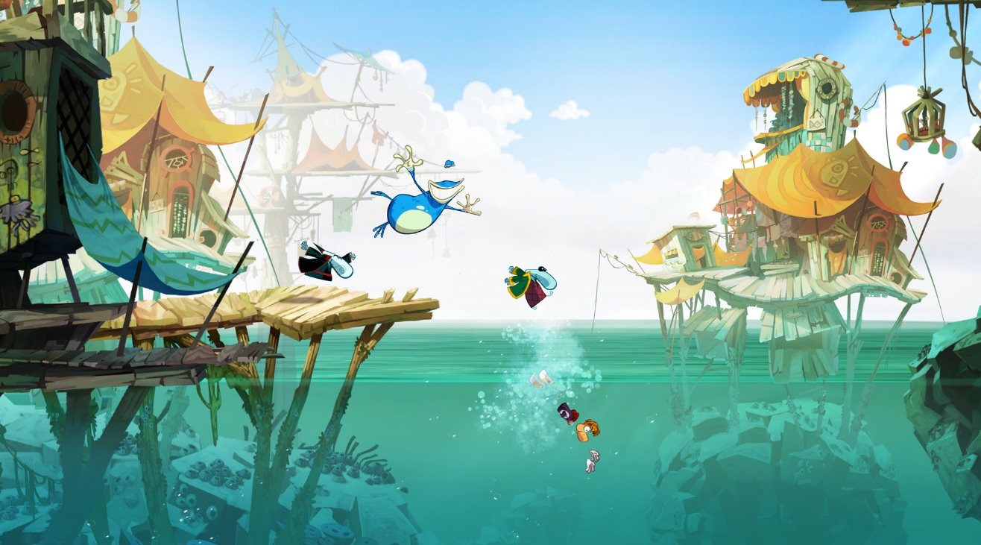

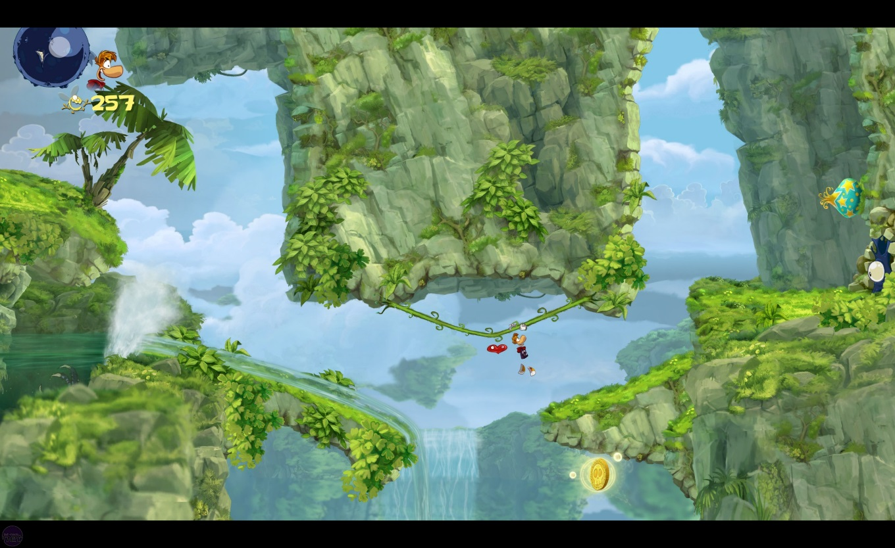

Player Composites:

1. Primary Target Players: Traditional platform gamers.

2. Secondary Target Players: Puzzle/Exploration lovers.

Example Player Profile:

John Doe, age 28, Salesman. Single. Graduated from Concordia University.

Fairly hardcore gamer, plays video games almost everyday for at least 1 hours, and with friends on consoles and PC. Focuses on action or platforming games (many titles from Xbox Arcade and the likes) such as Halo or LittleBigPlanet. He also watches sports including hockey and basketball and loves to go to movies. Drinks beer and eats nachos.

Game World:

The game world consists of four different maps combine together. They are: Forest Kingdom; Cave Kingdom; Frozen Kingdom and Cloud Kingdom. Each map contains different elements that are unique to that kingdom. The player needs to get to certain places to get powerups in order to get to the next stage.

The powerups that you can get give you the ability to progress further in the level. Without them you won’t be able to go further or even get back to where you need to in order to progress further. We chose to segment the map so that you had to do some exploring and you would get to see the beautiful scenery and have fun jumping around on the platforms. So once you get the first powerup you can progress into the cave where you have to do a lot of platform jumping, dodge some enemies and also make some really tight jumps in order to get to the second powerup. After gaining your double jump ability at the end of the cave, you now have the powers needed to ascend into the Cloud Kingdom and go fight the boss! The world was meticulously designed multiple times after tweaking jumping mechanics and gravity in order to feel good. So the distances between platforms are mostly equalized and you can get a good rhythm going down and also going back up in most places. Some parts of the level were designed to be purposely difficult to make the jumps and require the player to hone their jumping skills in order to hit the jump just right. It is challenging but not so difficult so that you will have to try it a bunch of times before getting it.

To help the player we have also implemented checkpoints that as you hit them will overwrite your last checkpoint to make it more friendly to move through the level while maintaining a certain level of progress so that the player doesn’t get too discouraged upon death.

Game Characters:

The player controls a guy in a black suit named Jisan that has the ability to kick enemies and jump over obstacles and between platforms. After attaining certain power ups, the player will be able to do a double jump or a spin kick.

Plot Graph:

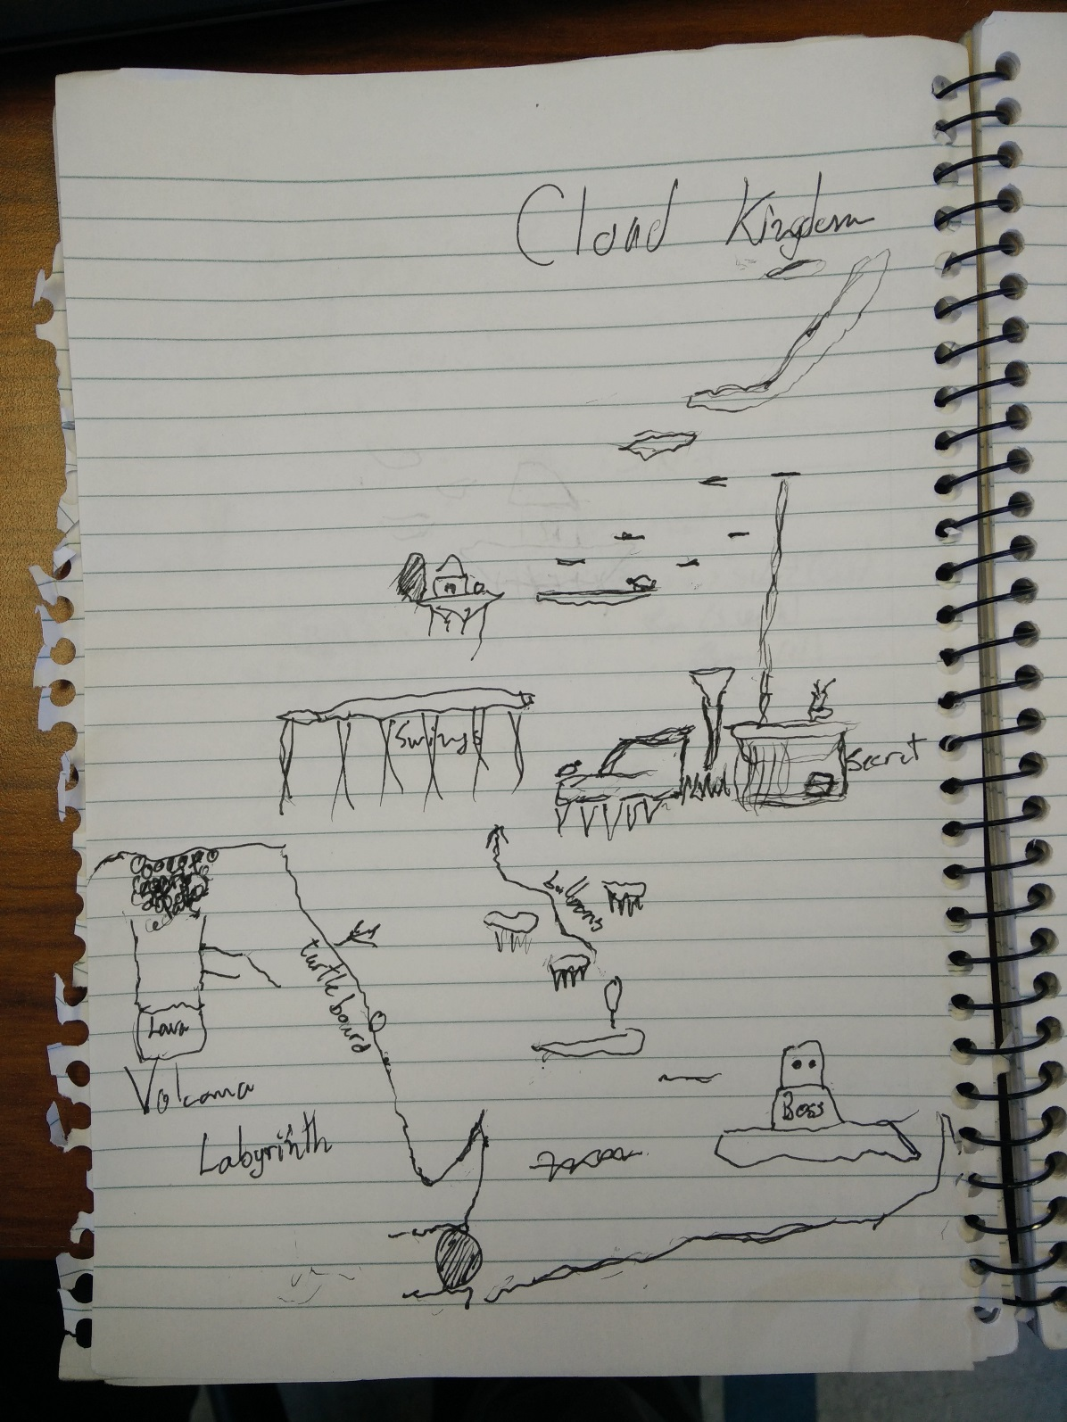

User Interface Design:

 Opening:

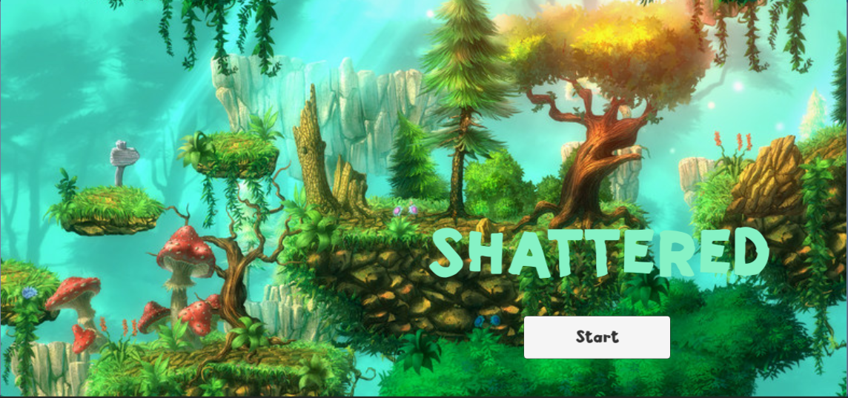

Pause Scene:

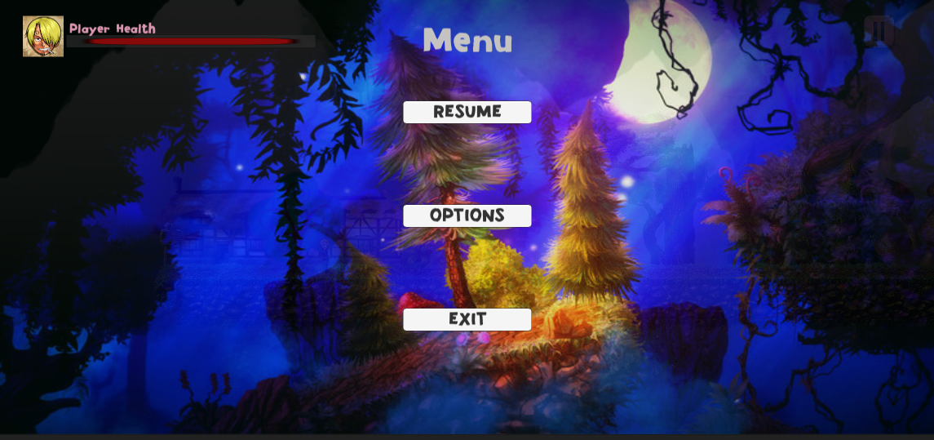

User Interface Design:

Player Health and Boss:

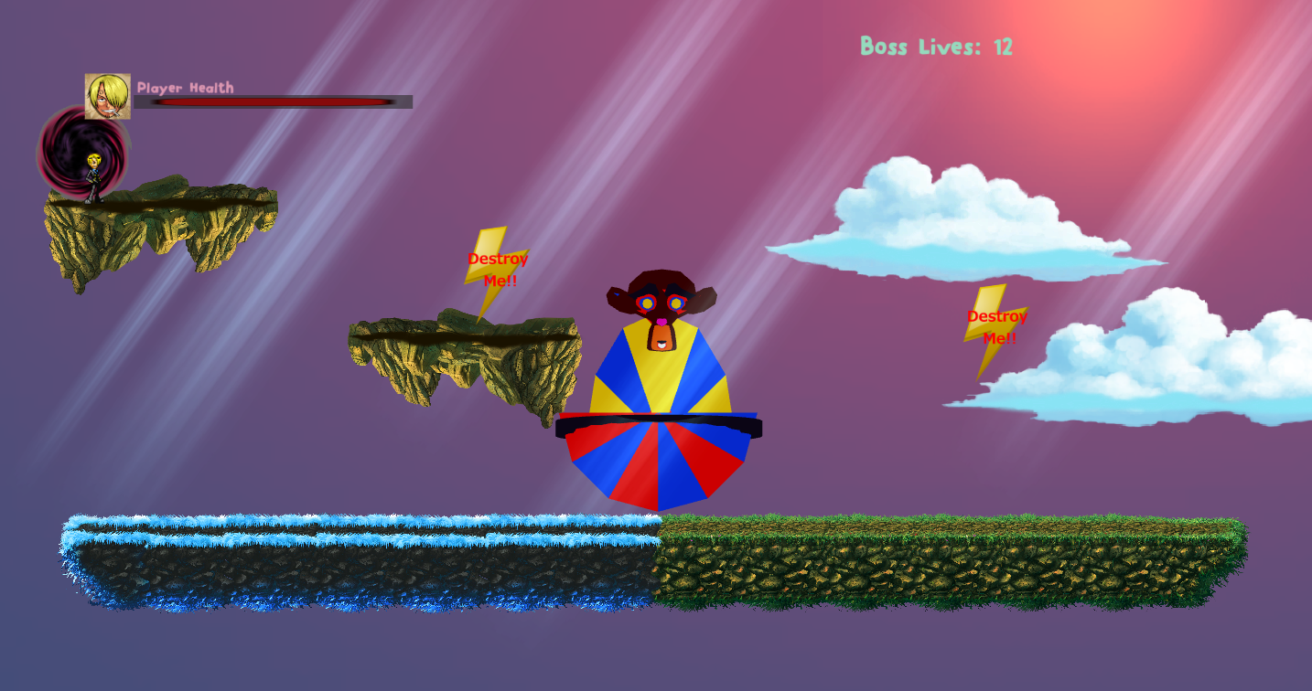

Game Over Scene (on player or boss death):

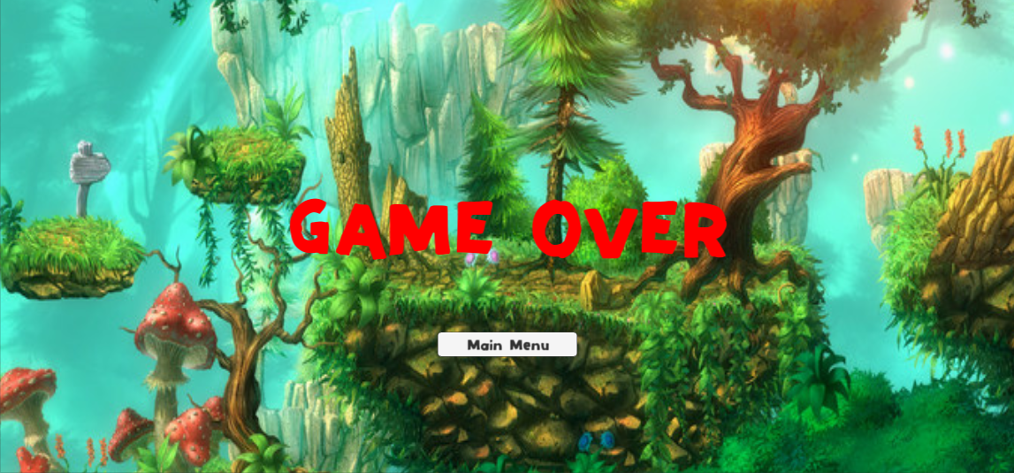

Technology Plan:

Software:

Unity—Game Development (Open Source engine)

MonoDevelop/Visual Studio – Scripting

Photoshop—Artwork

GIMP – Artwork

Slack—Development communicating

Trello—Development Tracking

GitHub – Changes in code

Dev Console (PCs and OS X);

Hardware:

PCs running Windows 7

Macbook Air running OS X

Software Architecture:

Unity Game engine and libraries.

Special thanks to Manufactura K4’s “2D Art Pack”. (2D sprites and materials) JuicyVitamin’s “2D Graphics pack” (Additional sprites) G.E.TeamDev’s “2D Sky” (cloud sprites)

Controls:

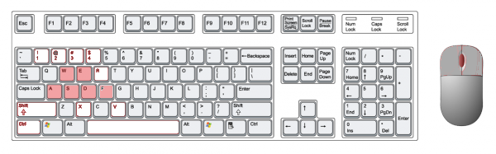

Right

Left

Confirm

Spin-Kick

Kick

Jump

Mechanics Analysis:

1. Open-world

The game does not have levels, we have four different areas within one map and we merged them together with transitional areas. The player has to make use of the entire map (with a couple small dead ends as exceptions) in order to reach the boss and beat the game.

2. Progression

There is a progression to the game and you cannot go further until you have reached certain areas and gotten certain powerups.

3. Puzzles as obstacles

The player has to figure out how to get past the glowing mushroom without really any help. Logically you have to attack it since you can’t walk through it and it looks out of place but it’s up to the player to figure out you have to use the powerup spin kick move to do it.

5. Combat Mechanics/Enemy Weaknesses

The player can dodge in combat, kick or spin kick in order to fight enemies. You always have to kick the boss in the head in order to do damage, there is a visual cue at the beginning telling the player to kick them in the head.

Schedule & Change Log:

May 3rd: Class starts;

May 10th: Brainstorming for ideas;

May 14th: Formalizing ideas—Theatrical Mishaps;

May 20th: Game Proposal Presentation;

May 23rd—June 3rd: Continue to work on the project;

June 3rd: Game Process Presentation;

Process since May 3rd:

Basic Scenery: Theater, Background, Lighting;

Basic Character: Robot;

Basic Animations: Walk, Jump;

June 3rd: Scrap the original idea due to the complicity of the 3D characters’ mechanics and created a new one;

June 5th—June 15th: Continue to work on the new project—Shattered;

June 15th: Game test play;

June 17th: Game Final Presentation;

June 17th—June 21st: Fixing bugs, implementing feedback from the teacher, teacher’s assistant and from other students in the class and finalizing the game;

Issue Tracking:

1: Change of idea, when there are 10 days left before the game testing we decided to change the original idea, which made us have less time than other teams.

2: Characters Mechanics: The main issue we had for the original idea is the 3D character mechanics, but 2D mechanics are also complicated, the mechanics that we created for the main character are :run, jump, kick, spin kick, double jump and die; We also made two kinds of enemies, one can attack and die and the other one can follow the player and attack. Last we created a final boss, the boss can follow the character and attack, final boss also have a saw that can spin 360 degrees to attack the main character.

3: Fixing bugs;

Budget:

0$